**21/04/2023**

**INTRODUCTION TO AWS**

**INTRODUCTION TO CLOUD COMPUTING**

**Server:**

* A powerful computer
* Can handle many PC
* Definitely contains CPU, memory, storage
* A device that provides a service to another computer program and its user, also know as the client

**On-premises:**

* A group of servers that you privately own, control and maintain yourself

**Expenses in on-premises:**

* Investment
* Construction cost
* Man power
* Server
* Networking cost
* Marketing
* Maintenance
* Physical Security
* Network Security

**Hypervisors:**

* To overcome the disadvantage of a physical server that can only run one application
* A Virtual Machine Monitor (VMM), is a software that creates and runs virtual machines (VMs)
* Allows one host computer to support multiple guest VMs by virtually sharing its resources, such as memory and processing

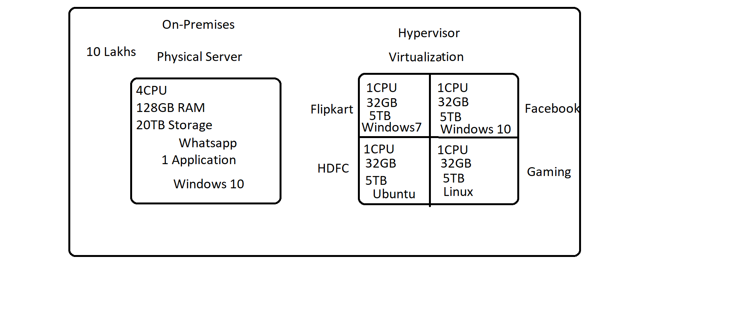

**Two types of Hypervisors:**

|  |  |
| --- | --- |
| **Type 1** | **Type2** |
| Bare metal architecture | Hosted architecture |
| A light weight OS and runs directly on the host’s hardware | Runs as a software layer on an OS, like other computers |
| What Is a Hypervisor? – Types, Benefits & How It Works | Park Place | What Is a Hypervisor? – Types, Benefits & How It Works | Park Place |

**Cloud Service Providers (CSP):**

* A cloud service provider is a third-party company offering a cloud-based platform, infrastructure, application, or storage services.
* Examples: AWS by Amazon, Azure by Microsoft, Google Cloud Platform by google, IBM, Oracle, Alibaba, etc

**Cloud Service Consumers:**

* IT sector
* Government sector
* Individuals

**Data centre:**

* A dedicated space or a building to store collection of data
* [Data centers](https://www.vmware.com/topics/glossary/content/data-center-solutions.html) contain physical or virtual servers that are connected internally and externally through networking and communication equipment to store, transfer and access digital information.
* Each server has a processor, storage space and memory, similar to a personal computer but with more power.

**What is cloud computing?**

* The on-demand delivery of IT resources over the internet with pay-as-you-go pricing.
* Instead of buying, owning and maintaining physical data centers and servers, you can access technology services, such as computing power, storage, and databases, on an as-needed basis from a cloud provider like AWS

**Cloud Service Models or Types of CSP:**

* There are three popular types of cloud service offerings

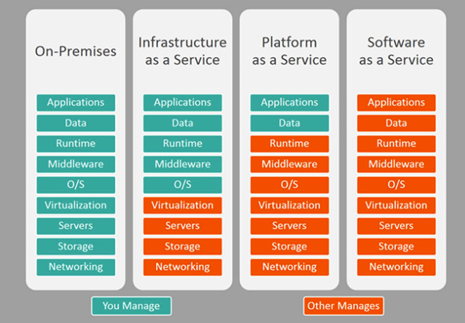

**Advantages of cloud computing:**

* No initial investment
* Unlimited storage
* Zero maintenance
* Autoscaling
* Globalisation
* Security

**IT resources:**

|  |  |
| --- | --- |
| Server | Infrastructure as a service |
| Storage |
| Network |
| Database | Platform as a service |
| Security |
| Application | Software as a service |

**SERVICES PROVIDED BY AWS**

**What is AWS?**

* A cloud service provider
* Has world wide data centers
* A platform that provides more than 200 fully featured services from data centers located all over the world
* Is the world's most comprehensive cloud platform
* Is an online platform that provides scalable and cost-effective cloud computing solutions
* Is a broadly adopted cloud platform that offers several on-demand operations like compute power, database storage, content delivery, etc., to help corporates scale and grow.

**History of AWS:**

* AWS started its first data center in Northern Virginia in the year of 2006
* Initially only two resources were introduced
  + Service – EC2
  + Storage – S3
* was initially designed to support the needs of Amazon's own e-commerce business but was soon made available to other businesses as a way to build, deploy, and scale applications in the cloud.

**AWS Global Infrastructure:**

* The most secure, extensive, and reliable Global Cloud Infrastructure
* Is designed and built to deliver a flexible, reliable, scalable, and secure cloud computing environment with high quality global network performance.

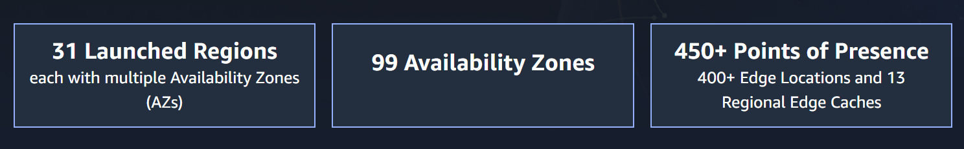

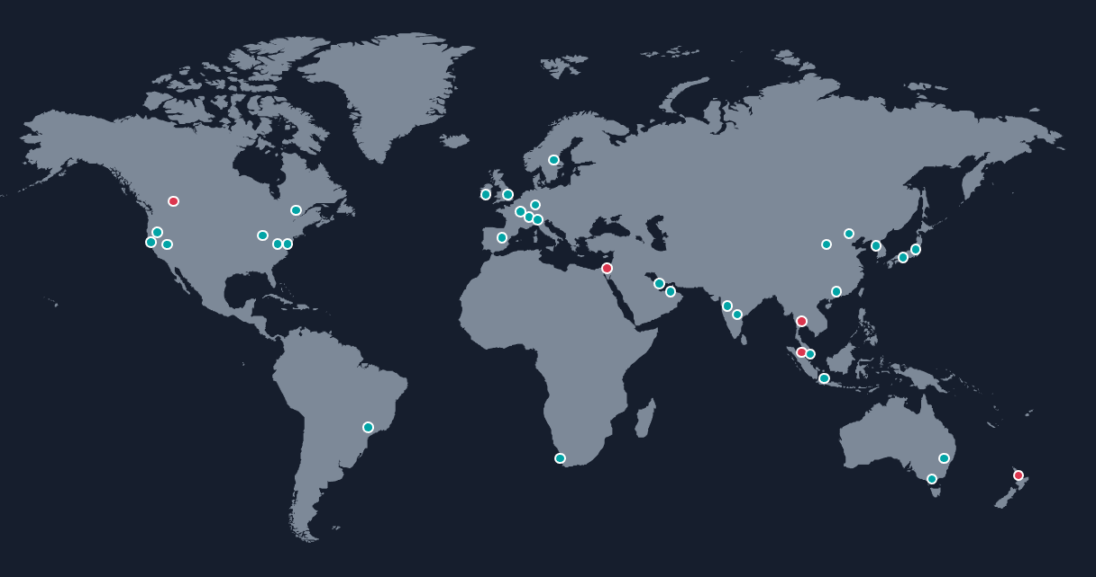

|  |
| --- |
|  |

**AWS Regions:**

* Is a geographical area.
* Data replication across regions is controlled by you
* Each Region provides full redundancy and connectivity to the network
* Typically consists of two or more Availability Zones
* To achieve fault tolerance and stability, Regions are isolated from one another
* Right region for your services, applications, and data are selected based on these factors:
  + Data governance, legal requirements
  + Proximity to customers (latency)
  + Services available within the region
  + Costs (vary by region)

**AWS Availability Zones:**

* Each region has multiple Availability Zones
* Each Availability Zone is a fully isolated partition of the AWS infrastructure
* Consists of discrete data centers
* Designed for fault isolation
* interconnected with other Availability Zones by using high-speed private networking
* You choose your availability zone
* Every region must have minimum 2 availability zones

|  |
| --- |
| How many servers does a data center have? - RackSolutions |

**AWS Data Centers:**

* AWS data centers are designed for security
* Data centers are where the data resides and data processing occurs
* Each data center has redundant power, networking, and connectivity, and is housed in a separate facility
* A data center typically has 50,000 to 80,000 physical servers

**Points of presence:**

* AWS provides a global network of Points of Presence locations
* Consists of edge locations and a much smaller number of Regional edge caches
* Used with Amazon CloudFront - A global Content Delivery Network (CDN), that delivers content to end users with reduced latency

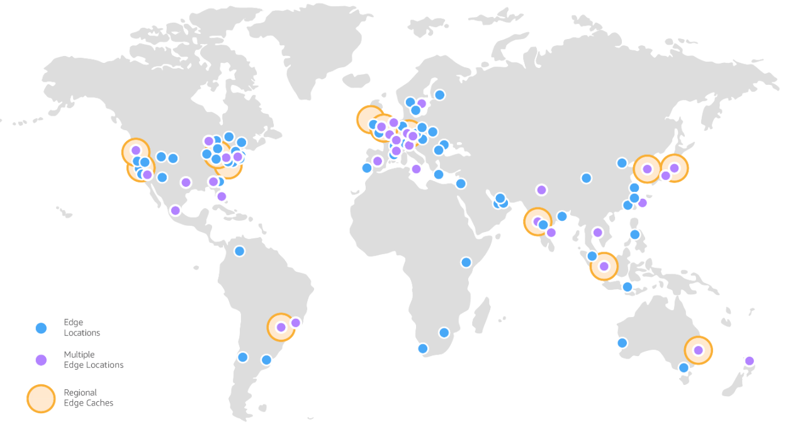

**Advantages of AWS:**

* Easy to use
* Flexible
* Cost-effective
* Reliable
* Scalable and high performance
* Secure

**Services provided by AWS:**

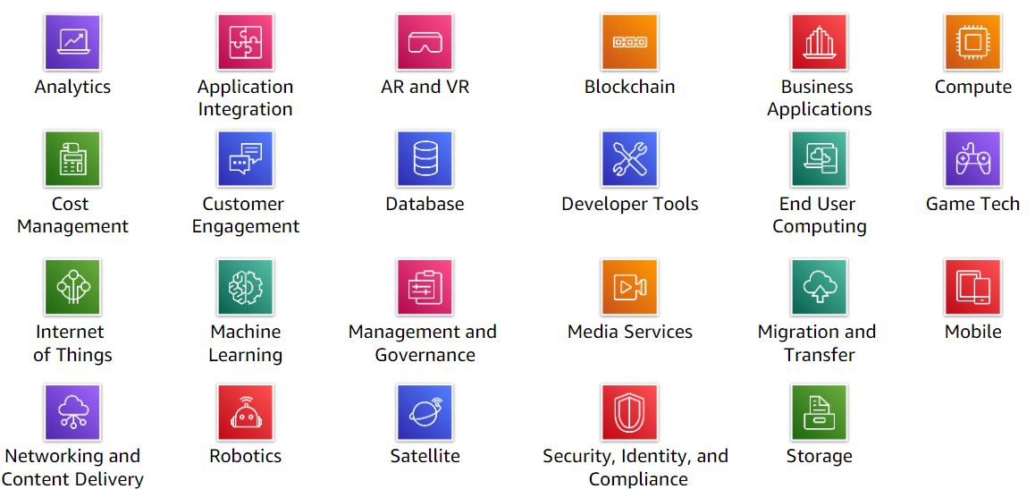

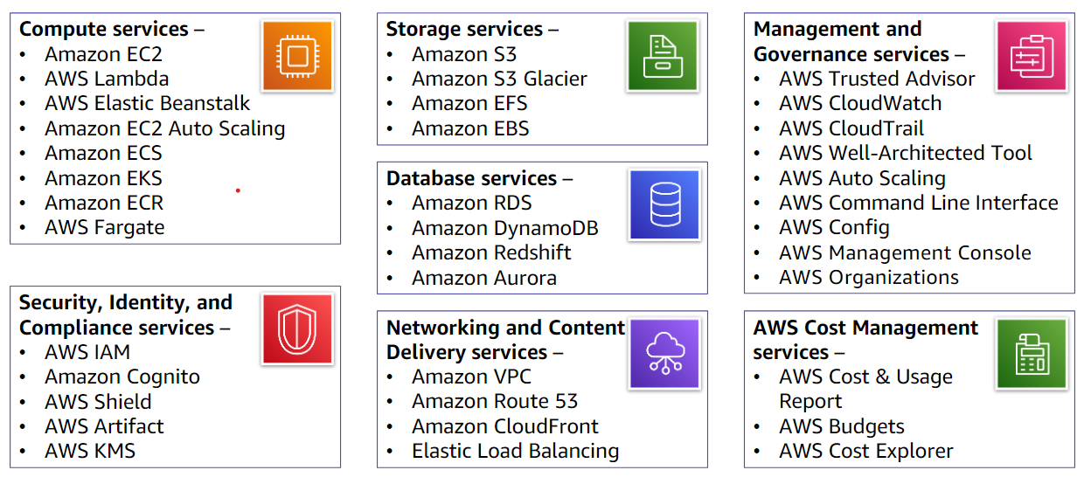

**FUTURE OF AWS**

**AWS ACCOUNT CREATION**

**Steps:**

1. Sign up using your email address
2. Verify your email address
3. Create your password
4. Add your contact information
5. Add a payment method
6. Verify your phone number
7. Choose an AWS support plan
8. Wait for account activation